**UNITED INSTITUTE OF TECHNOLOGY**

**CHATBOT DEPLOYMENT WITH IBM CLOUD WATSON ASSISTANT**

**MENTOR TEAM MEMBER**

NISHANTHI.H 1. YAMINIDEVI S - 714521104057

2.DHANALAKSHMI B - 714521104014

3.VISHNU S- 714521104056

4.CHARAN S.M- 714521104013

5.PRASHANTH M- 714521104035

6.BRITO JASON- 714521104012

**CHATBOT DEPLOYMENT WITH IBM CLOUD WATSON ASSISTANT**

**Abstract:**

Our aim to explore the process of deploying chatbots using IBM Cloud Watson Assistant And to customize the chatbot for popular messaging platforms like Facebook Messenger and Slack. Through this deployment, the aim to provide users with a helpful virtual guide that offers useful information, answers frequently asked questions, and delivers a friendly conversational experience. To Join as empower users with quick access to information and create meaningful connections through our virtual guide

**Problem statement:**

The problem statement for deploying a chatbot with IBM Cloud Watson Assistant is to create a virtual guide for popular messaging platforms like Facebook Messenger and Slack. The goal is to provide helpful information, answer frequently asked questions, and create a friendly conversational experience for the users.

**Module:**

1. Sign in to IBM Cloud account.
2. Go to the IBM Cloud Catalog and search for "Watson Assistant".
3. Select the Watson Assistant service and click on "Create".
4. Give the assistant a name and click on "Createassistant".
5. Configure the assistant by defining intents, entities, and dialog flow.
6. Train the assistant by providing sample user queries and appropriate responses.
7. Test the assistant to ensure that it understands and responds correctly.
8. Integrate your assistant into application or website using the provided SDKs or APIs.
9. Monitor and analyze the performance of your assistant to make improvements.
10. Deploy your chatbot and start engaging with users.

**INNOVATION DESIGN TO SOLVE THE PROBLEM**

**INTRODUCTION :**

* The Chatbot Deployment with IBM Cloud Watson Assistant, it's all about bringing the virtual assistant to life on popular messaging platforms like Facebook Messenger and Slack. The explore the exciting world of chatbot deployment together.
* It involves taking the chatbot created using Watson Assistant and making it available on various messaging platforms. It can deploy the chatbot on platforms like Facebook Messenger, Slack, and more, allowing users to interact with assistant through these popular messaging apps. It's a great way to reach and assist users in a more convenient and familiar environment
* The deployment of a chatbot using IBM Cloud Watson Assistant involves several key steps. After creating an IBM Cloud account and setting up a Watson Assistant instance, users navigate to the Watson Assistant dashboard. Here, they define intents, create entities, and build a dialog flow to specify the bot's responses.
* Training the chatbot refines its understanding, and thorough testing ensures accuracy. Integration options enable deployment in applications or websites. Ongoing monitoring, analysis, and iterative refinement based on user feedback are essential for maintaining an effective chatbot. This process empowers users to create dynamic and interactive conversational experiences.
* Cloud deployment is the process of hosting and running applications or services on remote servers instead of on local hardware. It offers benefits like scalability, flexibility, and accessibility. With cloud deployment, you can easily deploy and manage your applications without the need for physical infrastructure. It's a convenient and efficient way to ensure your applications are available to users anytime, anywhere.

**PROBLEM STATEMENT :**

* The problem statement for Chatbot Deployment with IBM Cloud Watson Assistant is to provide users with a user-friendly and efficient platform to deploy chatbots on the cloud. This platform should allow users to easily create conversational flows, define intents, and train their chatbots to provide accurate and helpful responses. Additionally, it should offer scalability, flexibility, and accessibility to ensure that the chatbots can handle increasing user demands and be accessible from anywhere. The goal is to enhance customer support and automate interactions through the deployment of intelligent chatbots.
* The highlights need for a comprehensive guide that demystifies the deployment process, enabling users to leverage IBM Cloud Watson Assistant effectively. By offering clear instructions and insights, this guide aims to empower businesses and developers to create and deploy chatbots that can seamlessly interact with users, ultimately driving enhanced customer satisfaction and operational efficiency.

**DESIGN ENHANCEMENT:**

The design steps for Chatbot Deployment with IBM Cloud Watson Assistant:

**1.Define the scope and purpose of chatbot:**

Determine what tasks or information chatbot will handle and how it will interact with users. The scope of a chatbot refers to its intended range of functionalities and the specific tasks it is designed to perform. The purpose of a chatbot is to provide automated assistance and engage in conversations with users, offering information, answering questions, and performing certain tasks. Chatbots can be used for various purposes, such as customer support, information retrieval, transactional tasks, and more.

**2. Gather and analyze user requirements:**

Understand the needs and expectations of your target audience to design a chatbot that meets their specific needs. Gathering and analyzing user requirements refers to the process of collecting information from users about their needs, preferences, and expectations for a particular product or service. This involves conducting research, interviews, surveys, and other methods to gather insights from users. Once the information is collected, it is then analyzed to identify common patterns, prioritize the requirements, and make informed decisions about the design and development of the product or service.

**3. Design the conversation flow:**

Map out the different user intents and create a logical flow of conversation that guides users towards their desired outcomes. Designing the conversation flow involves planning and structuring the way the conversation between a user and a chatbot unfolds. It includes determining the order and sequence of messages, understanding user intents, and crafting appropriate responses. The goal is to create a smooth and engaging conversation that guides users towards their desired outcomes. It's important to consider user inputs, provide clear instructions, handle errors gracefully, and offer relevant suggestions or prompts to keep the conversation flowing naturally.

**4. Create intents and entities:**

Define the intents (user intentions) and entities (specific information) that your chatbot will recognize and respond to. In the context of natural language processing, creating intents involves defining the purpose or goal of a user's input, such as identifying if the user wants to book a flight or order food. Entities, on the other hand, are specific pieces of information within the user's input, like the destination or the type of food. By creating intents and entities, we can train a machine learning model to understand and extract relevant information from user input.

**5. Build the dialog:**

Design the dialog flow by creating nodes that represent different steps in the conversation and define the responses for each node. Building the dialog involves creating the conversational structure and content for a chatbot. It includes defining user intents, designing dialog flows, and crafting responses based on those intents. The dialog should be designed to understand and fulfill user requests, provide relevant information, and guide users towards their desired outcomes. It's important to consider different user scenarios, handle variations in user inputs, and provide clear and concise responses. By building a well-designed dialog, you can create a seamless and engaging conversational experience for users. Let me know if you have any more questions or need further clarification

**6. Train the chatbot:**

Provide sample user queries and their corresponding responses to train the chatbot to understand and generate appropriate replies. To train a chatbot, you provide it with a dataset of example conversations and desired responses. The chatbot learns from this dataset to understand user inputs and generate appropriate replies. Training involves using machine learning techniques to optimize the chatbot's performance over time. It's an iterative process where the chatbot is continually refined and improved based on user feedback and real-world usage.

**7. Test and refine:**

Test your chatbot with various user inputs to ensure it responds accurately and handles different scenarios effectively. Refine and iterate on the design as needed. Testing and refining a chatbot involves evaluating its performance by simulating user interactions and analyzing the responses. During testing, you can identify any issues, errors, or areas for improvement in the chatbot's understanding and response generation. Based on the test results, you can refine the chatbot's training data, algorithms, or logic to enhance its accuracy and effectiveness. It's an iterative process that helps optimize the chatbot's performance and ensure a better user experience.

**8. Deploy the chatbot:**

Integrate the Watson Assistant API into your desired platform or application to make your chatbot accessible to users. To deploy a chatbot, you need to integrate it into a platform or channel where users can interact with it. This can be done by connecting the chatbot to messaging platforms like Facebook Messenger or Slack, or embedding it on a website or mobile app. Once deployed, users can engage with the chatbot and have conversations with it. It's important to ensure that the chatbot is properly configured and tested before deployment to provide a seamless and effective user experience.

**9. Monitor and improve:**

* Continuously monitor the performance of your chatbot, gather user feedback, and make improvements to enhance its effectiveness and user satisfaction. To deploy a chatbot, you need to integrate it into a platform or channel where users can interact with it. This can be done by connecting the chatbot to messaging platforms like Facebook Messenger or Slack, or embedding it on a website or mobile app. Once deployed, users can engage with the chatbot and have conversations with it. It's important to ensure that the chatbot is properly configured and tested before deployment to provide a seamless and effective user experience.
* These steps provide a general framework, and It may need to adapt them based on specific requirements and the capabilities of IBM Cloud Watson Assistant.
* In IBM Watson Assistant, which is a cloud-based conversational AI platform, entities, intents,
* and dialogs are key components used to build and train chatbots or virtual assistants. Here's a brief explanation of each:

# Entities:

* In Watson Assistant, an entity represents a specific piece of information within user input. It is used to extract relevant data from user messages. Entities can be things like dates, numbers, product names, or any other data you want to capture. You define entities to help the assistant understand and process user queries more effectively.
* For example, if you're building a chatbot for a restaurant, you might define an entity named "cuisine" to extract the type of cuisine the user is interested in (e.g., Italian, Chinese, Mexican).

# Intents:

* An intent is the purpose or goal expressed in a user's message. It represents what the user is trying to achieve or communicate. Intents are essential for routing user requests to the appropriate responses or actions. You define intents to help the assistant recognize and categorize user input accurately.
* For instance, in a virtual assistant for a bank, you might define intents like "Check Account Balance," "Transfer Funds," or "Report Lost Card" to identify the user's intentions.

# Dialogs:

* Dialogs in Watson Assistant are used to structure the conversation flow between the user and the chatbot. You create dialog nodes to define how the assistant should respond to user input based on detected intents and entities. Dialogs help in creating dynamic and context-aware interactions.
* Within a dialog node, you can define responses, conditions, and actions to take. You can also incorporate variables to store and retrieve information throughout the conversation, enabling personalized interactions.
* The typical workflow in Watson Assistant involves defining entities and intents, building dialog nodes to handle different conversation paths, and training the assistant using historical data or sample conversations. This training helps the assistant understand user input better, recognize intents and entities accurately, and respond appropriately.
* Entities, intents, and dialogs work together to enable natural and context-aware conversations between users and your chatbot or virtual assistant built with IBM Watson Assistant. By correctly defining and configuring these components, you can create effective and intelligent conversational interfaces.
* Now we are going to create the chatbot for that we will do the primary steps now.

# STEP1:

* Login To The IBM account and click on the Catalog and then search for Watson Assistant and give enter.

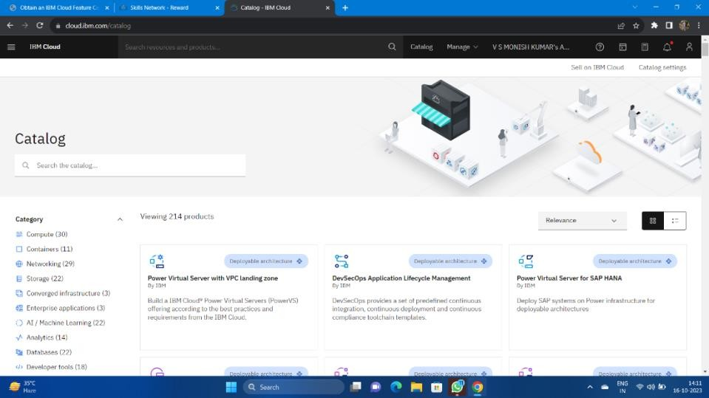

* You will get the Watson Assistant There By default you will have this

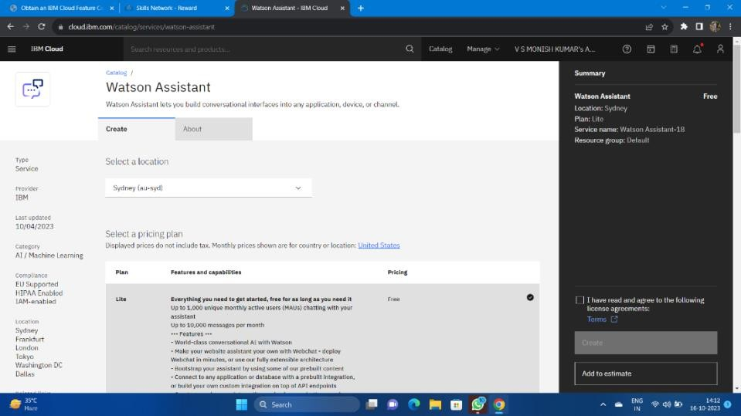

# Step 2:

* Change the default location and give the location as London(eu-gb) and select the plan as Lite

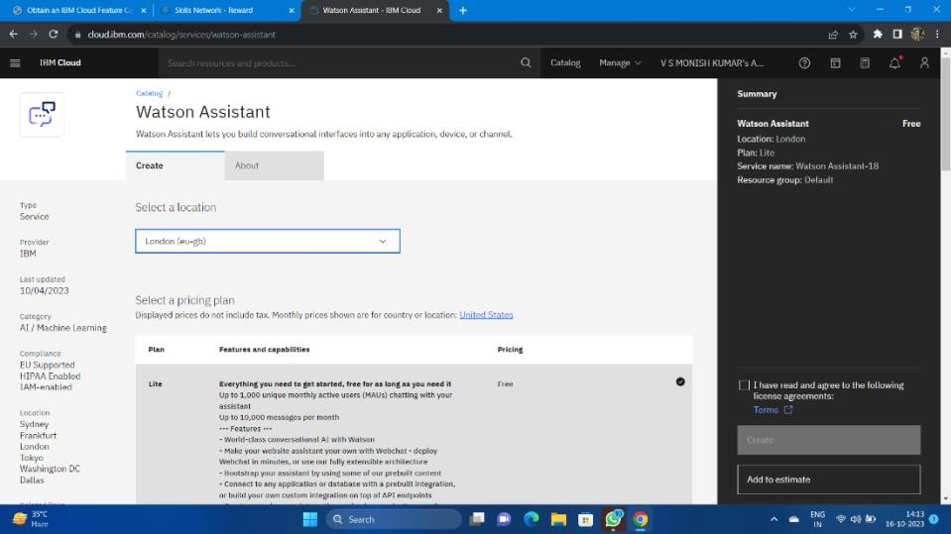

* Give tick mark for I have read and agree to the following license agreement

Now click on create it will create an instance for you

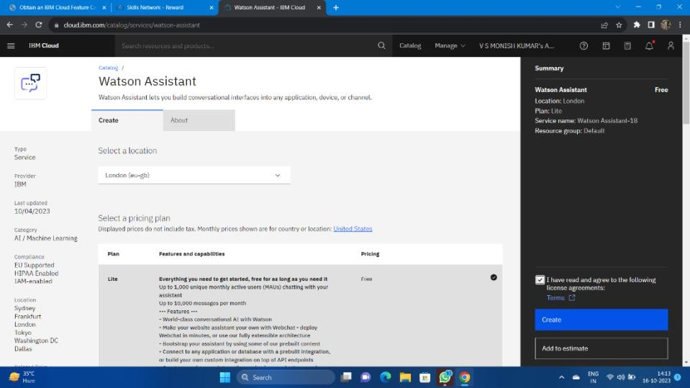

# Step 3:

* After creating an instance for Watson Assistant you need to launch the Watson Assistant by clicking the launch the assistant

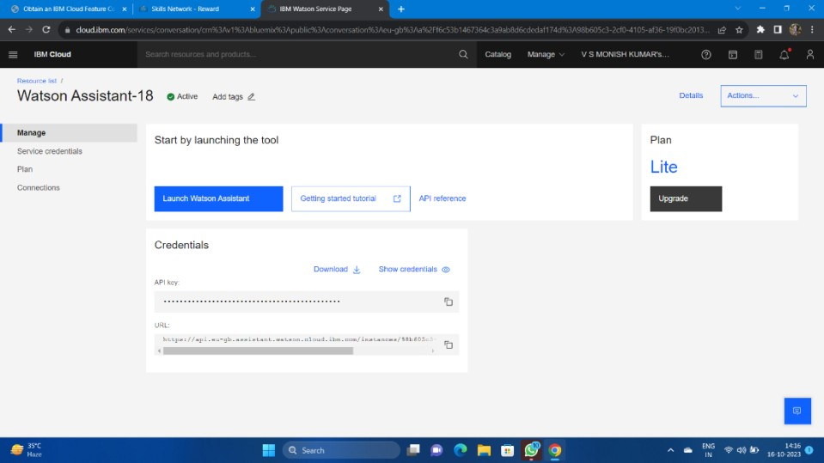

# Step 4:

* It will give the access to create the assistant give the name for the Assistant and give the description for that assistant it's completely optional click on create and save it.
* Here I have been created NM BOT as my chat bot assistant name .

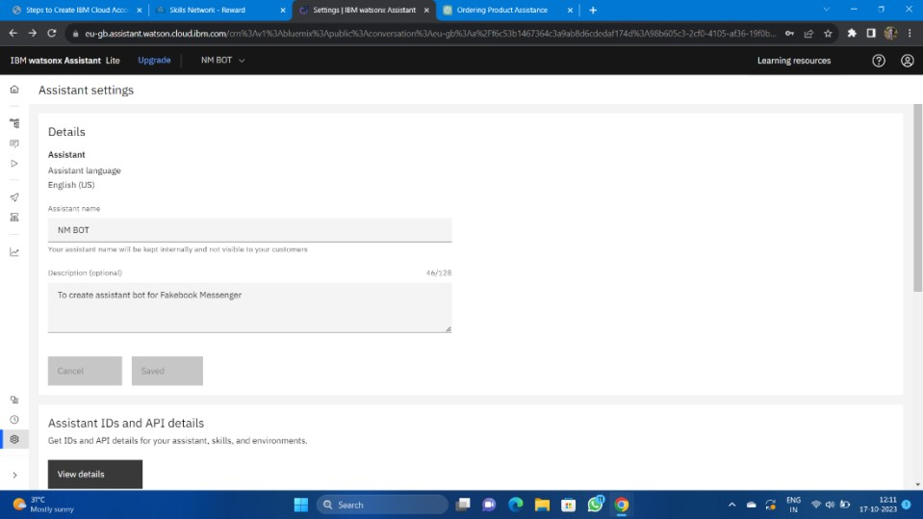

* Now scroll down and then activate the dialog

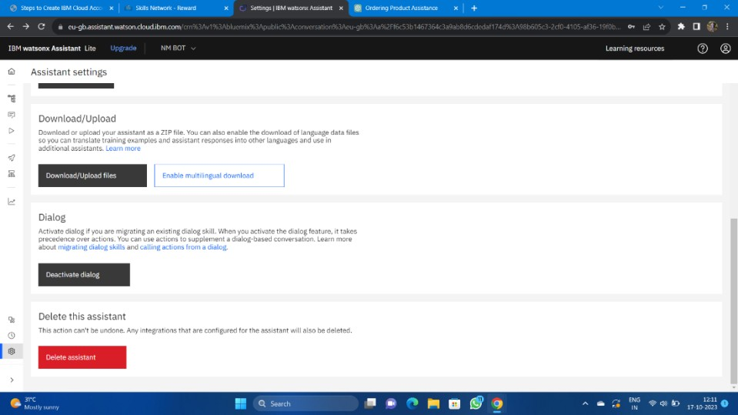

# Step 5:

* After activating the Dialog, you will get the Intents, Entities, Dialog, and Content catalog like shown below

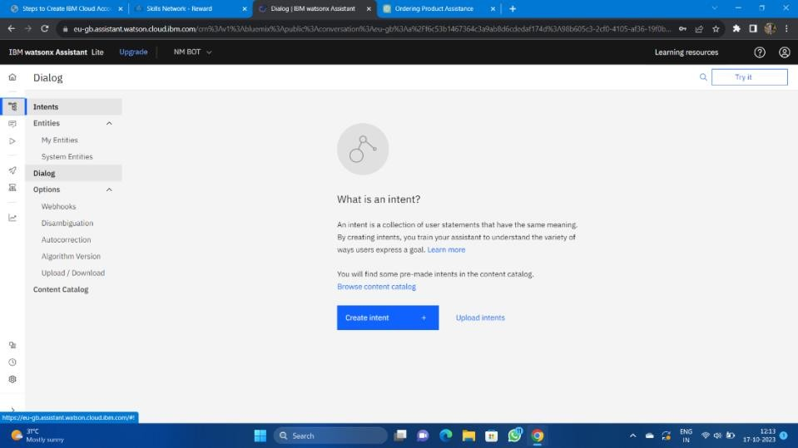

# Step 6:

* Create the Entities first and one variables for the entities you have been created.
* Here I have been created the Entity with the name Entertainement and added variables as channels and star with some variable value.

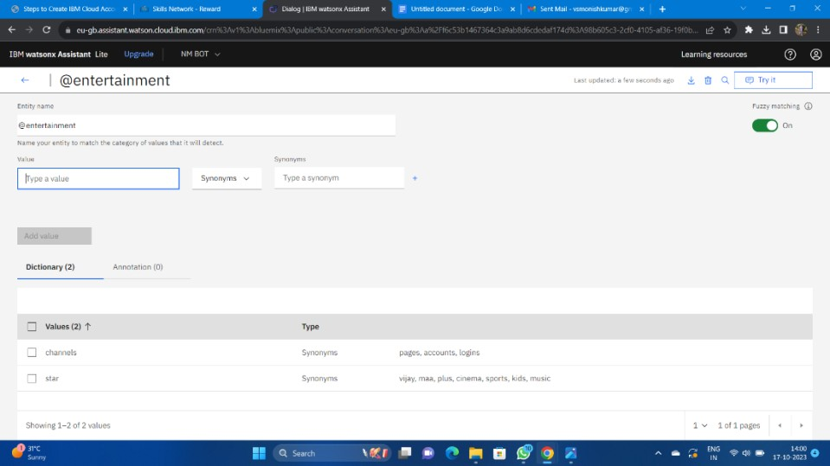

# Step 7:

* Open the Intents and then create the Intents for Messages, Services, AboutMe give some example queries for them

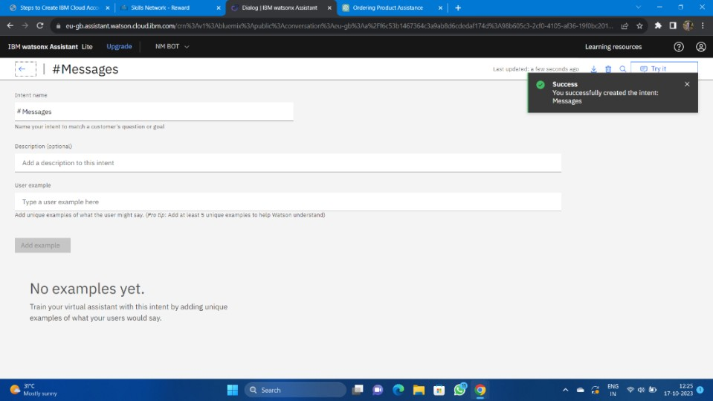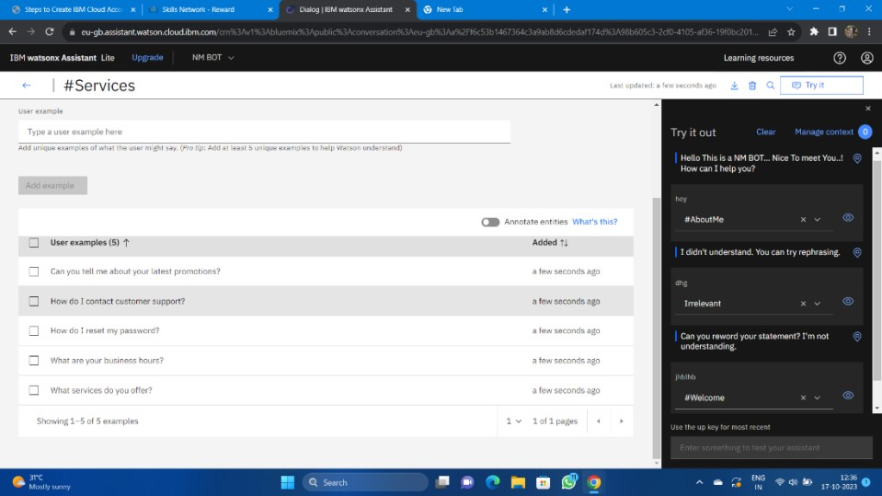

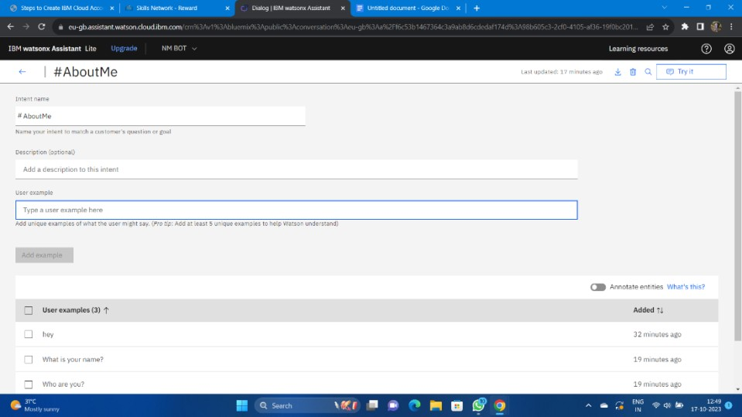

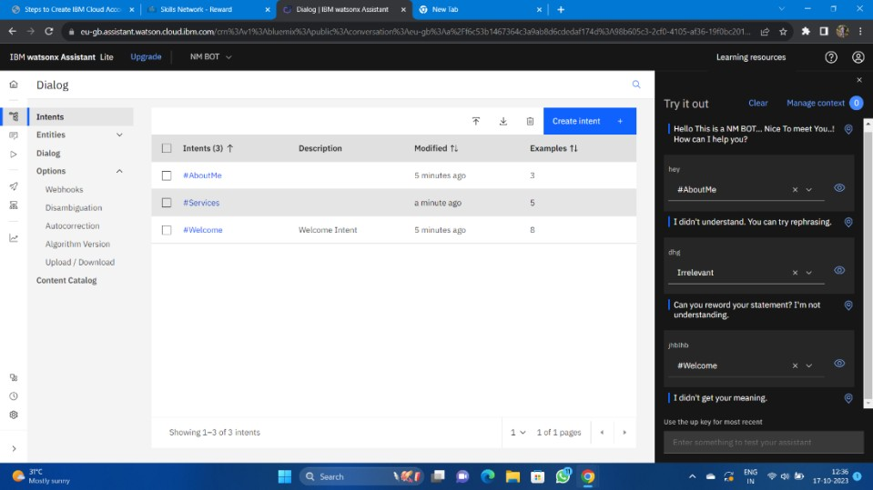

# Step 8:

* Next open the Dialog and then add nodes for all the Intents you have created where we need to give the responses for the selected queries.
* Whereby default we will have Anything else node.

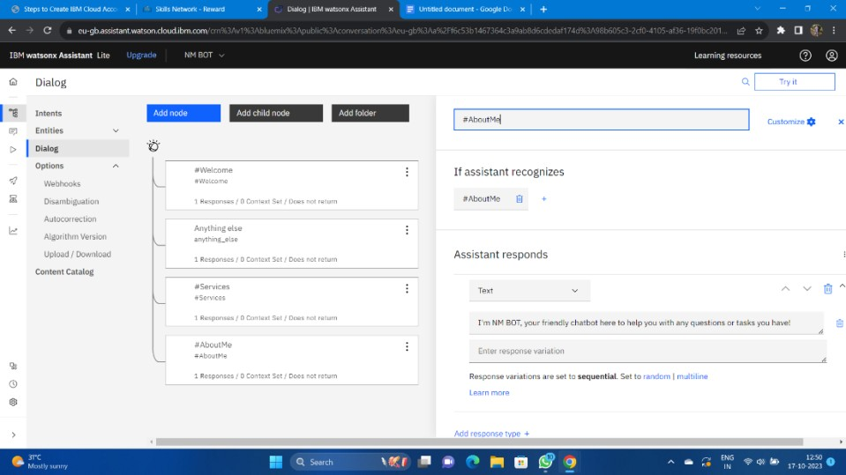

# Step 9:

* Check the chat bot by clicking the try it before connecting the Facebook Messenger.

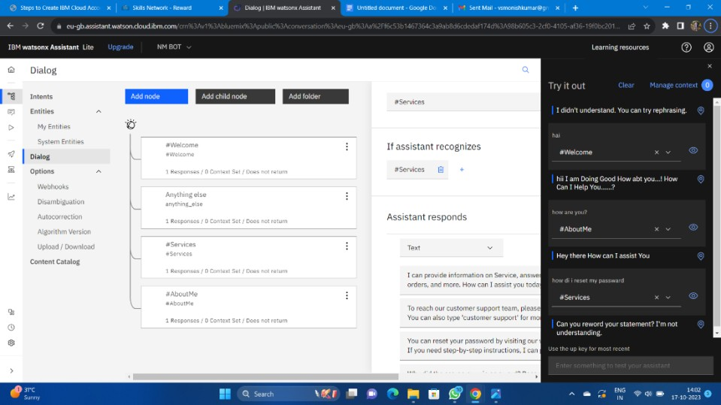

**SET IBM CLOUD WATSON ASSISTANT:**

* Sign in to IBM Cloud
* Go to IBM Cloud.
* Sign in with your credentials or create a new account.
* Create a Watson Assistant Service:

Once you're logged in, go to the IBM Cloud Catalog.

Search for "Watson Assistant" and select it.

Follow the prompts to create a new service instance.

Launch Watson Assistant:

* In your IBM Cloud dashboard, navigate to the Watson Assistant service you just created.
* Click "Launch Watson Assistant".

**DEFINE THE CHATBOT PERSONAL:**

* **Define the Chatbot's Purpose**

Determine the primary function of your chatbot (e.g., customer support, FAQ, recommendation engine, etc.).

* **Create a Persona:**

Decide on the personality and tone of your chatbot. Is it formal or casual? Friendly or professional? This will guide the way it interacts with users.

* **Provide a Name:**

Give your chatbot a name that aligns with its persona and purpose.

**DEFINE THE COVERSATION OF FLOW:**

* **Map Out the User Journey:**

Define the main topics or categories the chatbot will handle (e.g.,account inquiries, product recommendations, troubleshooting).

* **Create a Conversation Flowchart:**

Visualize how the conversation will progress, including possible

user inputs and chatbot responses.

* **Design the Greetings and Closings:**

Decide how the chatbot will greet users and how it will conclude conversation

**CONFIGURE INTENTS,ENTITIES AND DAILOG NODES:**

* **Configure Intents:**

Intents represent the user's intention in their message (e.g., asking a question, seeking information, expressing frustration).

Define a list of intents that your chatbot will recognize (e.g., "Greetings", "ProductInquiry", "Support").

* **Define Entities:**

Entities are specific pieces of information within user input (e.g., product names, dates, locations).

Create entities to help the chatbot extract relevant information.

* **Create Dialog Nodes:**

Dialog nodes define how the chatbot responds to different intents and entities.

For each intent, set up dialog nodes to handle various scenarios and guide the conversation.

**TRAIN AND TEST THE CHATBOT :**

* **Add Training Data:**

Provide sample user queries to train the chatbot. This helps it recognize intents and entities accurately.

* **Test in Preview Mode:**

Use the preview mode to interact with the chatbot and fine-tune its responses.

**ITERATE AND REFINE:**

* **Gather User Feedback:**

Collect feedback from users and make necessary adjustments based on their interactions.

* **Monitor and Analyze Performance:**

Keep an eye on the chatbot's performance metrics and use them to identify areas for improvement.

* **Continuously Update and Enhance:**

Regularly update the chatbot with new intents, entities, and dialog nodes as your system evolves.

**Source code:**

from ibm_watson

import AssistantV2

from ibm_cloud_sdk_core.authenticators

import IAMAuthenticator

authenticator = IAMAuthenticator('<your_watson_assistant_api_key>')

assistant = AssistantV2

(

version='2023-10-17',

authenticator=authenticator

)

assistant.set_service_url('<your_watson_assistant_service_url>')

input_message = {

'message_type': 'text',

'text': 'Hello'

}

session = assistant.create_session(

assistant_id='<your_assistant_id>'

).get_result()

session_id = session['session_id']

response = assistant.message(

assistant_id='<your_assistant_id>',

session_id=session_id,

input=input_message

).get_result()

response_text = response['output']['generic'][0]['text']

print('Watson Assistant:', response_text)

assistant.delete_session(

assistant_id='<your_assistant_id>',

session_id=session_id

)

